Peer Observation Form

Teacher Observed: Barger Date of Observation: 4/15/2019
Bb CC Link: https://sas.elluminate.com/site/external/jwsdetect/playback.jnlp?psid=2019-04-15.1021.M.2350B6DEBB622D534C5937D4AE5303.vcr&sid=559

DIRECTIONS:
- Only enter data/observations for areas observed in the lesson.
  - Some tenets of the domains will have no data.

Domain 1: Planning and Preparing
The components in Domain 1 outline how a teacher organizes the content of what students are expected to learn---in other words, how the teacher designs instruction. These include demonstrate knowledge of content and pedagogy, demonstrating knowledge of the students, selecting instructional goals, demonstrating knowledge of resources, designing coherent instruction, and assessing student learning.
A. Demonstrating Knowledge of Content & Pedagogy
- Knowledge of content and the structure of the discipline
- Knowledge of prerequisite relationships
- Knowledge of content-related pedagogy
Teacher Actions/Behaviors | Student Actions/Behaviors
Reviewed Important vocabulary for the days lesson. Taught the lesson in a structured way to make learning outcomes achievable.
B. Demonstrating Knowledge of Students
- Knowledge of characteristics of age group
- Knowledge of students’ varied approaches of learning
- Knowledge of students’ skills and knowledge
- Knowledge of students’ interests and cultural heritage
- Knowledge of students’ special needs
Teacher Actions/Behaviors | Student Actions/Behaviors
Made activity fun and engaging.
C. Setting Instructional Outcomes
- Value, sequence and alignment
- Clarity
- Suitability for diverse students
- Balance
Teacher Actions/Behaviors | Student Actions/Behaviors
D. Demonstrating Knowledge of Resources
- Resources for teaching
- Resources to extend knowledge and pedagogy
- Resources for students
Teacher Actions/Behaviors | Student Actions/Behaviors
E. Designing Coherent Instruction
- Learning activities
- Instructional materials and resources
- Instructional groups
- Lesson and unit structure
Teacher Actions/Behaviors | Student Actions/Behaviors
F. Designing Student Assessments
- Congruence with instructional goals
- Criteria and standards
- Design of formative assessments
- Use for planning
Teacher Actions/Behaviors | Student Actions/Behaviors

Domain 2: Classroom Environment
The components in Domain 2 consist of the interactions that occur in a classroom that are non instructional. These consist of creating an environment of respect and rapport among the students and with the teacher, establishing a culture for learning, managing classroom procedures, managing student behavior, and organizing the physical space.
A. Creating an Environment of Respect and Rapport
- Teacher interaction with students
- Student interaction with one another
Teacher Actions/Behaviors | Student Actions/Behaviors
The teacher interacted with students in chat. Teacher would often respond if a student made a mistake and explain the correct answer. | Student typed in chat or responded with polling.
B. Establishing a Culture for Learning
- Importance of the content
- Student pride in work
- Expectations for learning and achievement
Teacher Actions/Behaviors | Student Actions/Behaviors
C. Managing Classroom Procedures
- Management of instructional groups
- Management of transitions
- Management of materials and supplies
- Performance of non-instructional duties
- Supervision of volunteers and paraprofessionals
Teacher Actions/Behaviors | Student Actions/Behaviors
D. Managing Student Behavior
- Expectations
- Monitoring of student behavior
- Response of student misbehavior
Teacher Actions/Behaviors | Student Actions/Behaviors
Expectations clearly explained before each activity.
E. Organizing Physical Space
- Safety and accessibility
- Use of physical resources
Teacher Actions/Behaviors | Student Actions/Behaviors

Domain 3: Instruction
The components in Domain 3 are what constitute the core of teaching – the engagement of students in learning contest. These include communicating clearly and accurately, using questioning and discussion techniques, engaging students in learning, providing feedback to students, and demonstrating flexibility and responsiveness.
A. Communicating with Students
- Directions and procedures
- Oral and written language
Teacher Actions/Behaviors | Student Actions/Behaviors
Directions clearly identified and explained. | Breakout Room Activity- Broken into Partners.
B. Using Questioning and Discussion Techniques
- Quality of questions
- Discussion techniques
- Student participation
Teacher Actions/Behaviors | Student Actions/Behaviors
C. Engaging Students in Learning
- Representation of content
- Activities and assignments
- Grouping of students
- Instructional materials and resources
- Structure and pacing
Teacher Actions/Behaviors | Student Actions/Behaviors
Umpa Lumpa Punnett Square. | Student volunteer to participate and answer what is the genotype in the box.
D. Using Assessment in Instruction
- assessment criteria
- monitoring of student learning
- feedback to students
- student self-assessment and monitoring of progress
Teacher Actions/Behaviors | Student Actions/Behaviors
Tracker and talking to students during lesson about their responses. | Participating in chat and polling
E. Demonstrating Flexibility and Responsiveness
- Lesson adjustment
- Response to students
- Persistence
Teacher Actions/Behaviors | Student Actions/Behaviors

**Other Comments/Takeaways from the Observed Lesson
I liked the overall layout of the lesson.
Reviewed important vocabulary before you began the lesson.
Students actively participated in the Lesson.
Reflection on Lesson Objectives:
- Pre-Class POPcorn Time
- Define P Generation, F₁ Generation, F₂ Generation,
and Punnett Square.
- Identify symbols representing genetic traits.
- Perform one trait Mendelian crosses and record the
results using a Punnett Square. … ACTION ITEMS

You met and achieved all objectives for the lesson.
Questions I want to ask the teacher after my visit:
Do you think one day of instruction is enough on Punnett Squares?

What I might try in my classroom as a result of my visit:
I feel that we utilize a lot of the same practices with this particular lesson.
Do similar activities

Domain 4: Professional Responsibilities
The components in Domain 4 represent the wide range of a teacher’s responsibilities outside the classroom. These include reflecting on teaching, maintaining accurate records, communicating with families, contributing to the school and district, growing and developing professionally, and showing professionalism. Teachers who demonstrate these competencies are highly valued by their colleagues and administrators, as well as being seen as true professionals.
A. Reflection on Teaching
- Accuracy
- Use in future teaching
B. Maintaining Accurate Records
- Student completion of assignments
- Student progress in learning
- Non instructional records
C. Communicating with Families
- Information about the instructional program
- Information about individual students
- Engagement of families in the instructional program
D. Participating in a Professional Community
- Relationships with colleagues
- Service to the school
- Participation in school and district projects
E. Growing and Developing Professionally
- Enhancement of content knowledge and pedagogical skill
- Service to the profession
F. Showing Professionalism
- Integrity and ethical conduct
- Service to students
- Advocacy
- Decision making
- Compliance with school and district regulations

Partially adapted from:
https://www.andrews.edu/~rjo/Artifacts/Danielson's%20Framework%20for%20Professional%20Practice%20web.pdf

Started Class with Warm up Video and Questions.

1st Question “What are alleles” Student responses to this question in Chat.
2 Variations of a gene- we call these alleles.

How many squares are in a Punnett Square?- Students answered in Chat- ¼ or 25%.

Announcements-
Discussion Board 8 and Quiz 8 Closes.

No Class Over Spring Break- April 18- April 22.
PSSA- Window for Science- Review of Assignment Expectations during the PSSA Window. 5:29

Open your Quiz 9 Notes!!!!
2 Action items during class time.
File Transferred Notes- 7:35

Objectives 7:35-8:20

Review of Vocabulary- 8:30-14:15
Review of Phenotype- Round , Wrinkled
Review of Genotype- RR, Rr ,rr
Dominant Allele- Capital R is the Dominant Allele- Phenotype for Capital R is round, Recessive- for lowercase r- wrinkled
Homozygous Genotype- RR, rr
Heterozygous- Rr
Purebred- FF, ff- Review of Purebred
Explained a common misconception for students- Purebred in Genetics is different than the Term purebred in Dogs.

New Vocabulary Words: P Generation, F₁ Generation, F₂ Generation
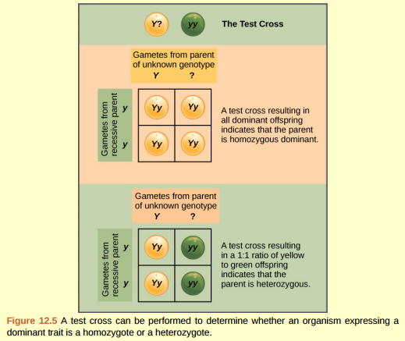
Screen Shot from Class:
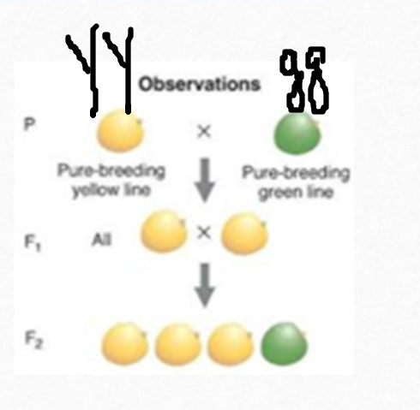

Y- Yellow is a the dominant Trait
y-green is a recessive trait

Ended At- 22:00
Mendel’s Results- Flower Color- Study Pea Plants for 8 years.
Purple Dominant Trait for Flower Color

Traits Mendel Studied- 7 Traits

Ended at 24:20
Punnett Squares- Vocabulary
Parent Genotype Placement
Location of Possible Offspring will be inside the Punnett Square

Shown students the Multiplication Square.
Show students where Parent Information is Located in Punnett Square
Show students how to distribute allele’s in Punnett Square.
Nice Detailed Instructions.

Example 1:
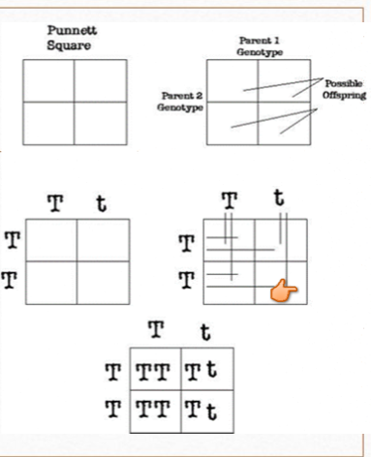
Review of Homozygous Dominant- What two Letters- TT
Review of Homozygous Recessive- What two Letters- tt
How many Homozygous dominant Possible Offspring do we have: 2 blocks
Heterozygous Yes 2 blocks
Homozygous Recessive: 0 Blocks

Phenotype- 100% Tall

Next slide 33:00-38:00
Dominant allele and Trait- F= Funny
Recessive allele and trait- f= not funny
Student Volunteers to fill in Punnett Squares- Blocks 1,2,3,4
Great student volunteers and participation.

Partner Time- Group Breakout Room:
Clear instructions on what students will be doing in breakout room activities.
Student given 4 minutes to work in Breakout Rooms

Students checking work when returned to the main room.
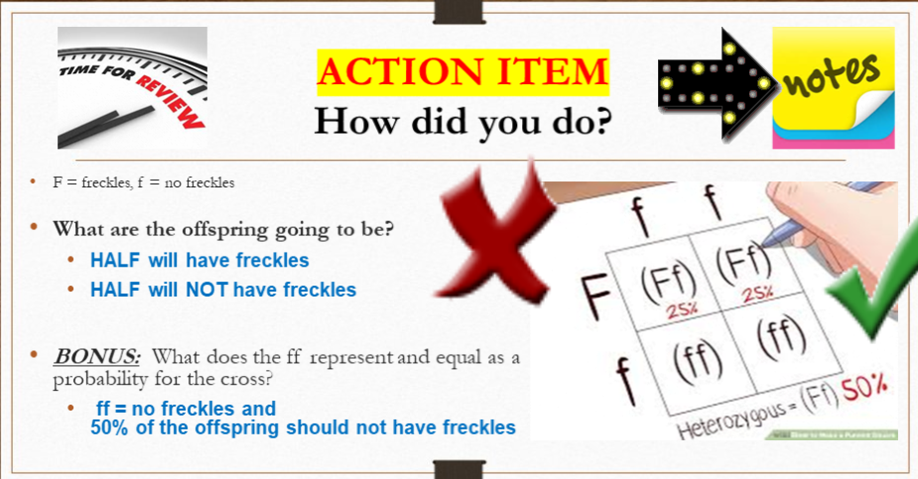
Data Filled in by Teachers- Students answering questions in Chat. 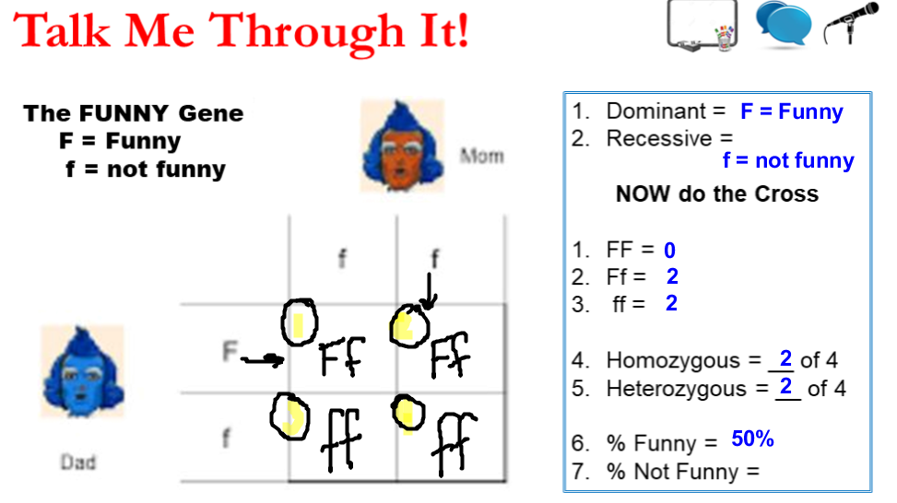

Action Item for Students to complete Independently.

48:15 Time in Recording. Students working in Private Breakout Room.
Student Work Time on Action Item
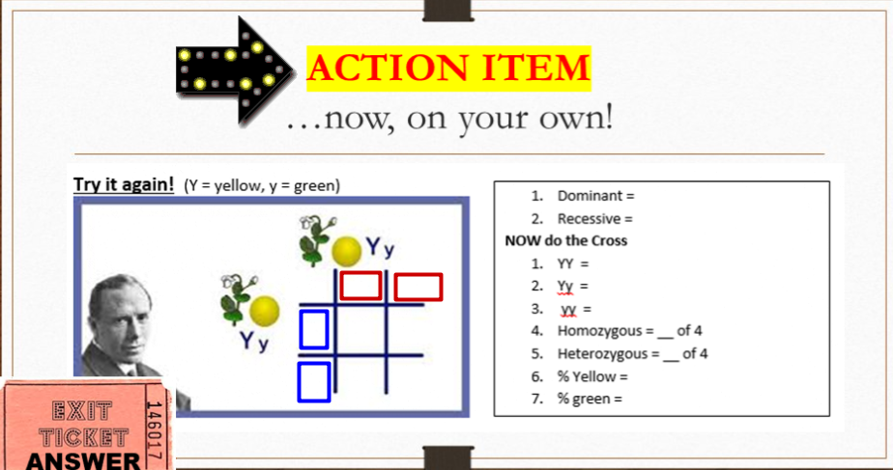

Students given answer to check work once they returned to the Main Room.
End of Class.

