Peer Observation Form

Teacher Observed: Tammy Barger Date of Observation: 4/8/2019
Bb CC Link: https://sas.elluminate.com/site/external/jwsdetect/playback.jnlp?psid=2019-04-08.0554.M.1485E33F8776BF18A460810C98048A.vcr&sid=559

DIRECTIONS:
- Only enter data/observations for areas observed in the lesson.
  - Some tenets of the domains will have no data.

Domain 1: Planning and Preparing
The components in Domain 1 outline how a teacher organizes the content of what students are expected to learn---in other words, how the teacher designs instruction. These include demonstrate knowledge of content and pedagogy, demonstrating knowledge of the students, selecting instructional goals, demonstrating knowledge of resources, designing coherent instruction, and assessing student learning.
A. Demonstrating Knowledge of Content & Pedagogy
- Knowledge of content and the structure of the discipline
- Knowledge of prerequisite relationships
- Knowledge of content-related pedagogy
Teacher Actions/Behaviors | Student Actions/Behaviors
Teacher clearly has knowledge of prerequisite relationships. Taught students in a chronological order in genetics to increase student understanding. Phenotype relating back to genotype. | Students participating in chat and polling.
B. Demonstrating Knowledge of Students
- Knowledge of characteristics of age group
- Knowledge of students’ varied approaches of learning
- Knowledge of students’ skills and knowledge
- Knowledge of students’ interests and cultural heritage
- Knowledge of students’ special needs
Teacher Actions/Behaviors | Student Actions/Behaviors
Student interests- Dogs and Animals | Student responded in chat.
C. Setting Instructional Outcomes
- Value, sequence and alignment
- Clarity
- Suitability for diverse students
- Balance
Teacher Actions/Behaviors | Student Actions/Behaviors
D. Demonstrating Knowledge of Resources
- Resources for teaching
- Resources to extend knowledge and pedagogy
- Resources for students
Teacher Actions/Behaviors | Student Actions/Behaviors
Study Guide distributed to students in Email before class.  In class Video Genotype and Phenotypes | Students use it as a resource.  Students preview Video during class.
E. Designing Coherent Instruction
- Learning activities
- Instructional materials and resources
- Instructional groups
- Lesson and unit structure
Teacher Actions/Behaviors | Student Actions/Behaviors
F. Designing Student Assessments
- Congruence with instructional goals
- Criteria and standards
- Design of formative assessments
- Use for planning
Teacher Actions/Behaviors | Student Actions/Behaviors

Domain 2: Classroom Environment
The components in Domain 2 consist of the interactions that occur in a classroom that are non instructional. These consist of creating an environment of respect and rapport among the students and with the teacher, establishing a culture for learning, managing classroom procedures, managing student behavior, and organizing the physical space.
A. Creating an Environment of Respect and Rapport
- Teacher interaction with students
- Student interaction with one another
Teacher Actions/Behaviors | Student Actions/Behaviors
Teacher was positive and encouraging with students. Trying to get them to engage in the course materials. | Students respond in chat and polling.
B. Establishing a Culture for Learning
- Importance of the content
- Student pride in work
- Expectations for learning and achievement
Teacher Actions/Behaviors | Student Actions/Behaviors
Expectations for learning/ engagement in class. | Students engage and participate in lesson
C. Managing Classroom Procedures
- Management of instructional groups
- Management of transitions
- Management of materials and supplies
- Performance of non-instructional duties
- Supervision of volunteers and paraprofessionals
Teacher Actions/Behaviors | Student Actions/Behaviors
Very good flow in the Breakout room activity. | Students answer questions on Escape room activity.
D. Managing Student Behavior
- Expectations
- Monitoring of student behavior
- Response of student misbehavior
Teacher Actions/Behaviors | Student Actions/Behaviors
Clear student expectations.
E. Organizing Physical Space
- Safety and accessibility
- Use of physical resources
Teacher Actions/Behaviors | Student Actions/Behaviors

Domain 3: Instruction
The components in Domain 3 are what constitute the core of teaching – the engagement of students in learning contest. These include communicating clearly and accurately, using questioning and discussion techniques, engaging students in learning, providing feedback to students, and demonstrating flexibility and responsiveness.
A. Communicating with Students
- Directions and procedures
- Oral and written language
Teacher Actions/Behaviors | Student Actions/Behaviors
Student tasks were given to students during lesson.  Directions are clear and easy to follow. | Students respond by polling/ chat/ microphone.
B. Using Questioning and Discussion Techniques
- Quality of questions
- Discussion techniques
- Student participation
Teacher Actions/Behaviors | Student Actions/Behaviors
C. Engaging Students in Learning
- Representation of content
- Activities and assignments
- Grouping of students
- Instructional materials and resources
- Structure and pacing
Teacher Actions/Behaviors | Student Actions/Behaviors
Activities- Images/Photos- Phenotype  Breakout Room Activities- Escape room. | Gave Clear instructions for the breakout rooms. to Easy instructions for students to follow.
D. Using Assessment in Instruction
- assessment criteria
- monitoring of student learning
- feedback to students
- student self-assessment and monitoring of progress
Teacher Actions/Behaviors | Student Actions/Behaviors
Formative assessment- Exit Ticket.  Teacher tried to engaged students that were not responding or participating in class.  Breakout Room Activity | Complete Exit Ticket/ Escape room activity.
E. Demonstrating Flexibility and Responsiveness
- Lesson adjustment
- Response to students
- Persistence
Teacher Actions/Behaviors | Student Actions/Behaviors

**Other Comments/Takeaways from the Observed Lesson

Reflection on Lesson Objectives:
After the lesson students that were participating and engaged in the lesson should understand of Phenotype, Genotype and Allele.
Clearly reviewed Phenotype and Genotype and Allele.

Questions I want to ask the teacher after my visit:
Could we make this slide easier to understand for the students in the class:
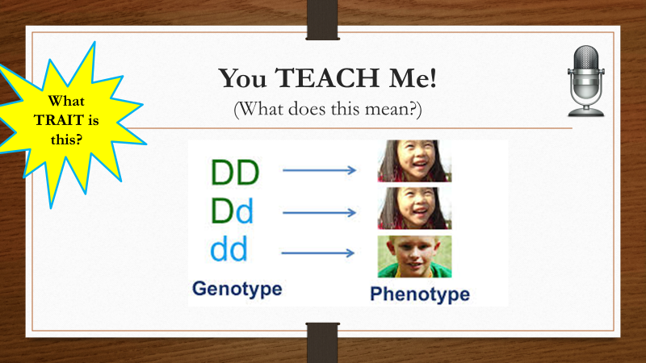

I think the content was good on this slide. I do think the genotype (Dimples) took the students a minute to understand. I feel gave students trouble when connecting what the question was asking. I feel this took away from the students understanding..

What I might try in my classroom as a result of my visit:

I am going to try this activity later this week:
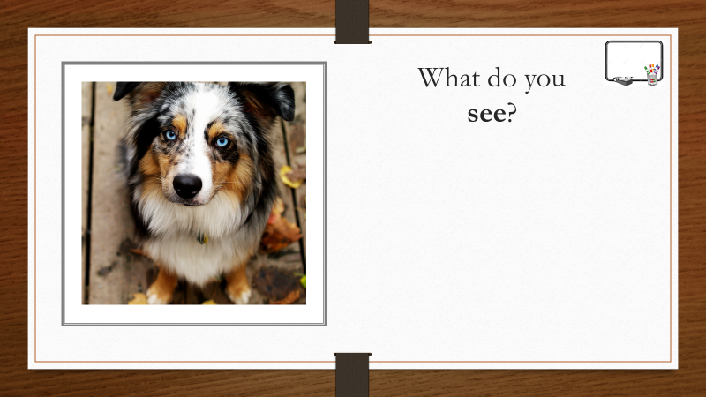
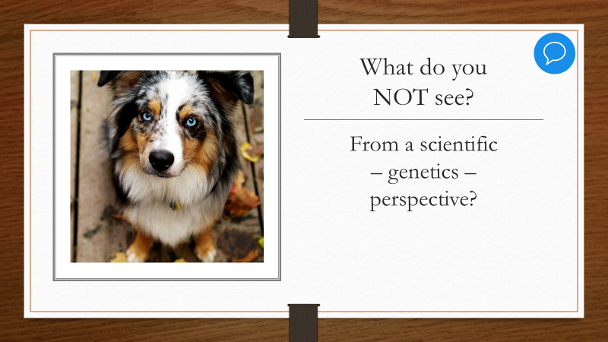

Domain 4: Professional Responsibilities
The components in Domain 4 represent the wide range of a teacher’s responsibilities outside the classroom. These include reflecting on teaching, maintaining accurate records, communicating with families, contributing to the school and district, growing and developing professionally, and showing professionalism. Teachers who demonstrate these competencies are highly valued by their colleagues and administrators, as well as being seen as true professionals.
A. Reflection on Teaching
- Accuracy
- Use in future teaching
B. Maintaining Accurate Records
- Student completion of assignments
- Student progress in learning
- Non instructional records
C. Communicating with Families
- Information about the instructional program
- Information about individual students
- Engagement of families in the instructional program
D. Participating in a Professional Community
- Relationships with colleagues
- Service to the school
- Participation in school and district projects
E. Growing and Developing Professionally
- Enhancement of content knowledge and pedagogical skill
- Service to the profession
F. Showing Professionalism
- Integrity and ethical conduct
- Service to students
- Advocacy
- Decision making
- Compliance with school and district regulations

Partially adapted from:
https://www.andrews.edu/~rjo/Artifacts/Danielson's%20Framework%20for%20Professional%20Practice%20web.pdf

Notes:
Announcements- 0-1:01
16 out of 25 Responded to your Announcements.

Phenotype vs Genotype Slides: - 1:02- 6:22
Asked Students to explain the between Phenotype vs Genotype.
Students Watched Video:
17-28 Responded in Polling.
Nice voice over explaining the difference between Phenotype and Genotype.

Do you have your notes open? 6:23- 17 out of 28 Responded
Encouraged students to update polling and participate.

Objective Slides: Teacher reviewed the Agenda for the class Section.

Making Connections Slide. 8-17-10:15
Nice job explaining the content is connected.

Review: Traits and Genes slide- 10:16- 17:45
Students used Whiteboard Tools- Firefly tool.
Could you use this slide as an individual breakout room slide?
Could we make this more student focused vs class focused?
Review of traits that students missed in slide.
Leaf and migration
Reviewed- Learned behaviors and inherited traits

Genes Slides: 17:46-19:28
Explained Chromosomes
Explained that chromosomes are made of DNA
Genes are sections of DNA That code for a specific Protein.

What do you see: dog slide 19:29- 21:27:
Teacher Statement: What do you see in the Photo
Dog with Blue Eyes,
Brown, White, black, and gray fur.

Asked students what they were describing of the dog. Phenotype:

Phenotype- 21:28- 23:30
Student Volunteer read Slides
Asked for Questions.

Gloves, Shoes Slide- 25 minutes
Student identified that shoes and Gloves come in Pairs in Chats.

Alleles Slide 25:16
Student Reader.
Explained that Alleles come from each Parent
1 Comes from the father, 1 comes from the mother.

What do you not see in this picture: 27:10:
We Do not see the dog’s genetic make-up.
Genotype

Genotype slide- 28:47- 31:47
Student reader.
Explained that alleles come from parents. 1 from each parent.
Asked for questions

You teach Me slide- 31:50-36.36
Asked for a student to explain.
Asked students to send a private chat.
Dimples vs no dimples
Could we make this example clearer in class?
I think this part was confusing to students.

Student did a great job explaining the Genotype.
Student did not initially explain phenotype.
Another student jumped on the microphone and explained the phenotypes for the 3 examples.
Action item Slide 36:40-42:00 Students updated Study Guide and filled in the correct answers.
Less than 50% completed it in class.

Escape Room Time- Clear directions.
Reviewed Answers for Escape room slides.

Wrap up and Exit Ticket.

