Running Notes for STUDENT NAME for MTSS Referral

Date | Subject Area/Teacher | Notes
2/23/18 | Science/Barger | Attempted appsharing with STUDENT NAME to get him into the quiz. He did not repsond until I put his name on the board and asked him to raise his hand when there. He then appshared, took the quiz and kept the appshare going so I could monitor him as he worked on 5 overdue assignments and his History quiz.

2/26/18 | Science/Barger | PARENT NAME (LC) logged into the session at 2:01 pm and logged out as soon as I asked if she had any questions (2:31 pm). No Exit Ticket.

2/27/18 | Science/Barger | attended, responded to some check questions/polling; did not complete Exit Ticket

2/28/18 | Science/Barger | Attended the session; did not complete the writing assignment

3/1/18 | Science/Barger | absent

3/2/18 | Science/Barger | Tardy 4 minutes; logged into quiz after much prompting - did not complete the quiz, was removed from the room.

(During a meeting with MTSS Coordinator, we were told we could complete notes weekly vs. daily)

Wk of Mar 5-9 | Science | 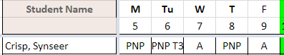  NO work completed

Wk of 3/12 | Science | 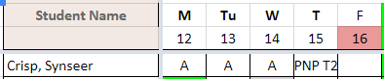  No work completion on ASY day either.

Wk of 3/19 | Science | 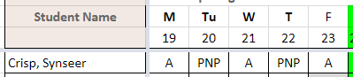

Etc.

